CA-17 High Precision Cleaver
Weight & Dimension
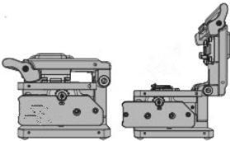
Dimension: 63(W)*75(D)*62(H)mm
Weight:400g(0.88lb)

User Manual

1. Key Features
- High Precision cleaver, applied to Single Fiber (250µm,900µm, 3.0mm, indoor fiber) and 2-12 cores Ribbon Fiber
- Total 24 cleave blade end faces, and each blade end face can be used 3000 times, can totally use 72000 times.
- Average cleave angle less than 0.5°.
- Easily operate, both on hand or desk, and right or left hand.
- Easily load the fiber, the cleaver can auto-reset, improve the work
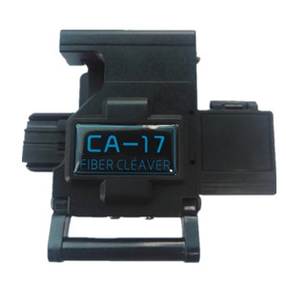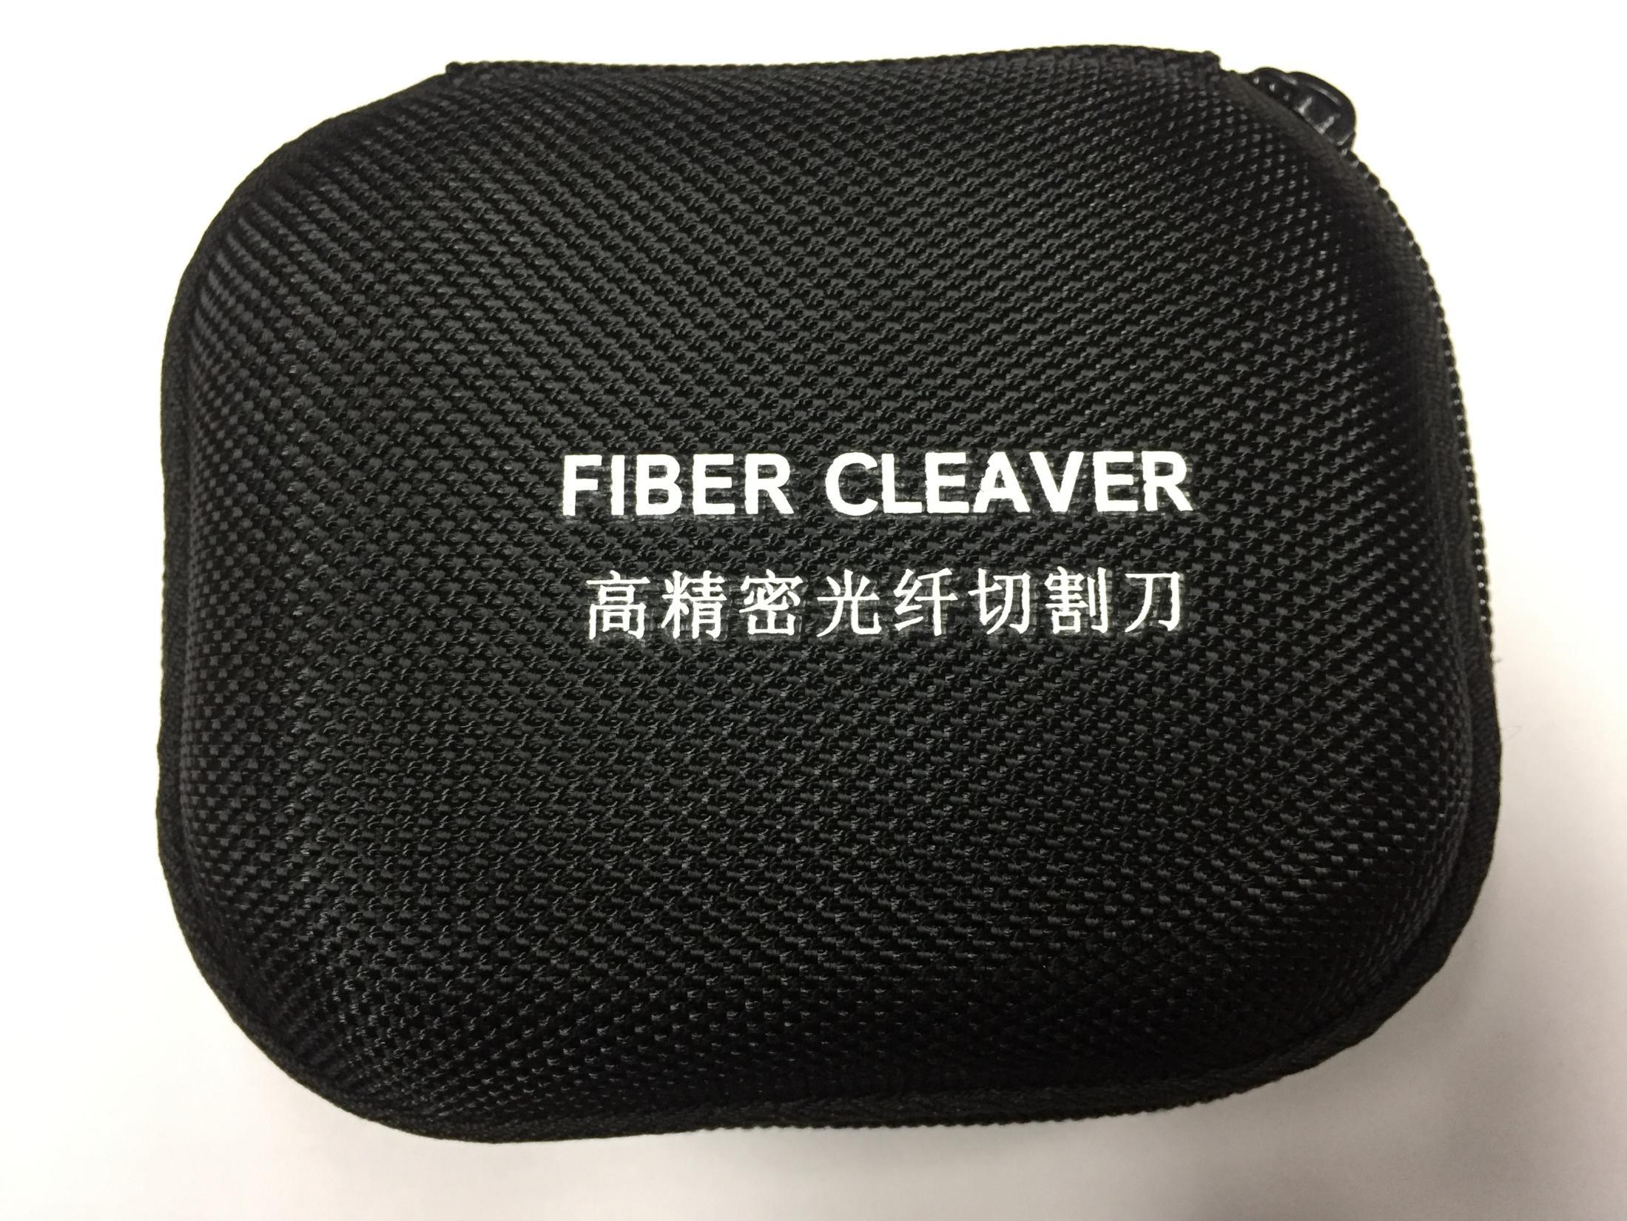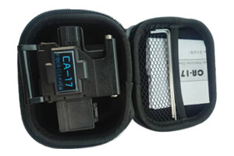

Cleaver | 1 pc
Blade type | 20*4*3  (12 end faces)
Warranty Card | 1 pc
1.5mm Hexagon Wrench | 1 pc
2.5mm Hexagon Wrench | 1 pc
Package box | 1 pc
Additional
Fiber Fixture | FH-SOC(for hot-melt )
Fiber Fixture | FH-12R(for 12 cores)

efficiency.
- Artful fiber clamp design, and prevent the fiber damage caused by
secondary cutting.
- Produced with magnesium alloy materials, small size, light weight,
High intensity and fashion appearance.
- Anti-skid design for bottom, to make sure cleaver stable and safe when working.
Package

2. Structure
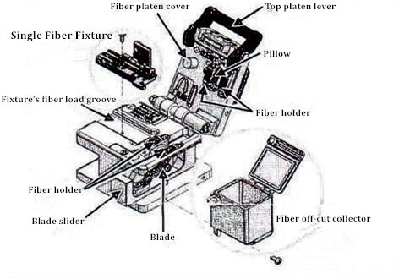

4. Blade Adjustment

After many times of cleave, a symptom that the fiber can’t be cleaved, cracks appear in end face, when it continued to happen, need to adjust the position of blade, then can use the new side of blade.

1. Use a screwdriver to loosen the screw and rotate the blade to a new end face (Use the cotton swab to press the blade flank or front, and push the blade outwards to make rotate operation easier.)
After finishing rotating, tighten the blade fixed screw
Reference: Tighten the screw properly, about 0.98Nm (10 kgf.cm)

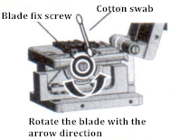

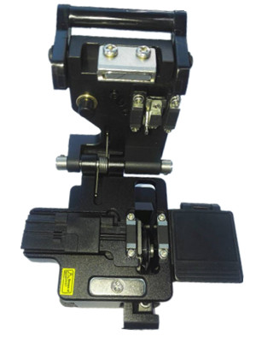
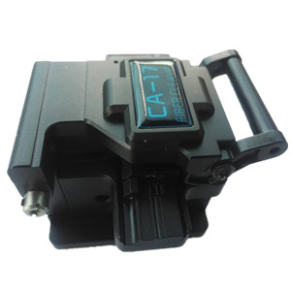

3. Specification

Model | CA-17 Single Fiber & Ribbon Fiber Cleaver
Cladding Diameter | 125µm
Cutting Length | Single Fiber: 8—20mm/ Ribbon fiber:10mm
Applicable Fiber | Single Fiber:250µm,900µm, 3.0mm/Ribbon Fiber: 2—12 core ribbon cable
Average Cutting Angle | Less than 0.5°
Blade Life | 72000 times(1000Times×24End face×3Height)
Operation Steps | 2 steps
Reset Function | Blade reset
Fiber Fixture | Single fiber: Universal fiber fixture/ Ribbon fiber: Replaceable ribbon fiber fixture

▪ Do not rotate the blade with hands.
▪ Do not rotate the blade with metallic tweezers.
▪ The blade will be damaged if use metallic tweezers
▪ Do not fix the blade too tightly, to avoid the screw damage



Blade adjust method
After many times of cleave, a symptom that the fiber can’t be cleaved, cracks appear in end face, when it continued to happen, need to adjust the position of blade, then can use the new side of blade. (Reference) 3000 fiber per position (3 times of height)

2. Try to cleave the fiber 1~3 times, and place it on fusion splice V-groove and judge the cleave quality by screen. If the end face is unqualified, please
adjust the blade height.

7. Troubleshooting
5. Blade Height Adjustment

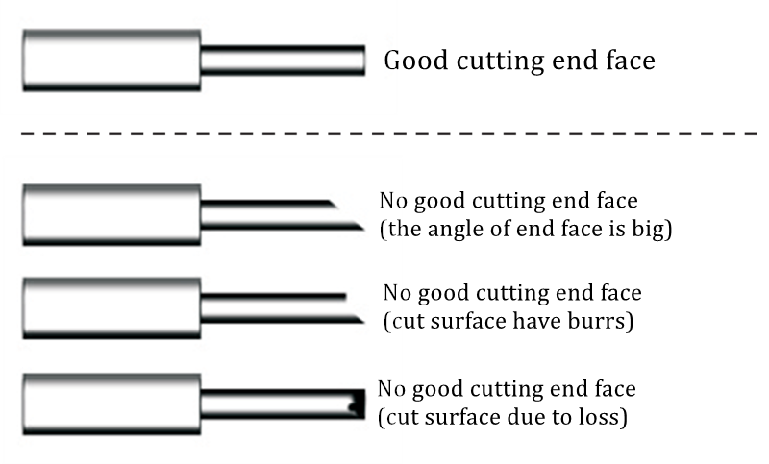
1. If have cleaver has a fiber off-cut collector, take out it at first.
2. Loosen the 2 fixed screw, and then loosen the screw which is fixed the blade

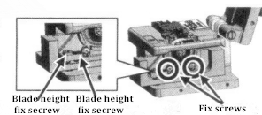

3. Place a mechanical pencil lead a light stick on clamp. Slide the blade carriage back and turn the blade height adjustment screw. The point where the lead barely touches the edge of the blade is a reference point (0µm)

Cutting defects may be caused by the following:
(A) The fiber is placed obliquely
Method: Make sure that the fiber is placed straight in the cleaver.
(B) The blade height is too high.
Method: Adjust the blade height.
(C) Dust or dirt remains on the clamp.
Method: Clean the clamp.
(D) Dust or dirt remains on the blade
Method: Clean the blade.
(E) Dust or dirt remains on the fiber.
Method: Remove the fiber coating and clean the bare fiber again.

Please contact our maintenance service center if it still happen

6. CA-17 Cleaver Testing Analysis

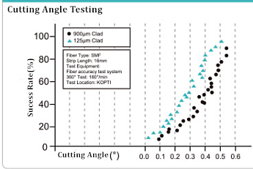
▪ Dust or fragment on the blade edge or the clamp might
cause loss of cleaving performance or poor quality of fiber end face.
▪ Do not clean them with any other kind of chemicals.

To keep the performance of the cleaver, cleaning after use it, with the cotton swab moistened with isopropyl alcohol. Wipe the blade, fiber clamp and pillow block.

8. Cleaning Method

