CA-25 Fiber Cleaver
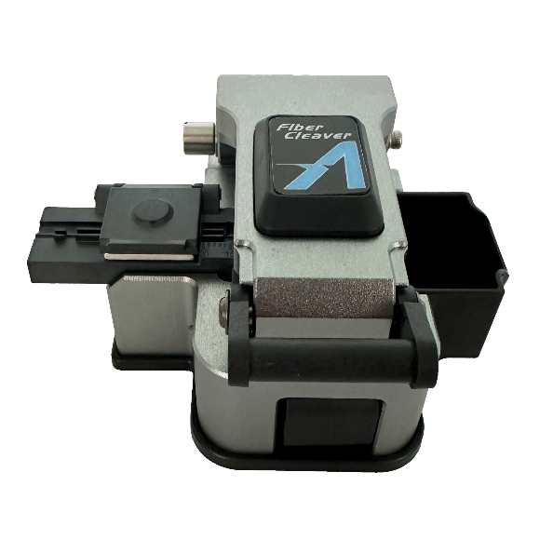
Applicable bare fiber diameter: 125µm
Applicable Fiber Core: Single Core
Applicable parameters of fixture:5~20+mm
Average cutting angle: ≤0.5°
Blade life: ≥48000 times (16*1000*3)
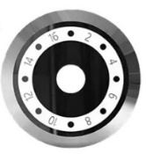
Blade type: ɸ22(mm)ɕ4(mm) H:2(mm)
Dimension:91W*82D*51H(mm)
Weight:231g
Fiber Fixture: Four in one fixture

Mark 1: 16-position blade * 1000 cuts per edge * 3 height settings

