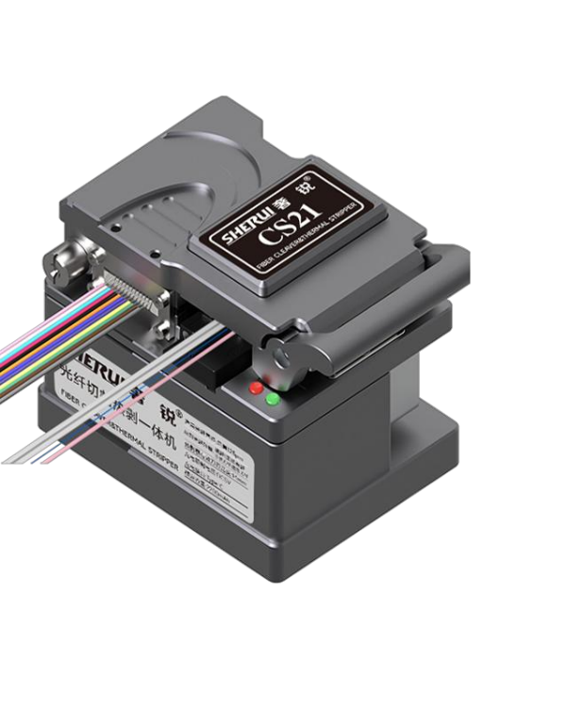
CS-01 Optical Fiber Cleaver with Thermal Stripper
Key features
- 2-in-1 multifunction cleaver can operation fiber cutting
and thermal stripping by only one machine
- CNC machining with all mental machine body,
fine workmanship
- Small size, user-friendly
- Built-in 2200mAh battery, type-C charging port
- 3 gears of temperature settings
- Use ribbon fiber holder can realize cleave 12 cores and strip 12 cores simultaneously, improve working efficiency
Specification
Cladding Diameter | 125μm
Applicable Fiber Type | Fanout fiber /bare fiber/ribbon fiber/ invisible fiber
Cutting Length | 10~20+mm (Visual); 5~20+mm (Estimable)
Average cutting Angle | ≤0.6°
Fiber Holder | 4-in-1multifunction
Battery Capacity | 7.4V /2200mAh
Temperature Gears | 145℃/160℃/70℃
Countdown time | 5 secs
Auto Power Off | 10 mins
Power Supply | 5V 1A ，Type-C charging Port
Blade edge width | 14mm
Dimension | 57W*83D*66H(mm)
Weight | 450g
Standard Configuration | Fiber Cleaver*1; Protection carry case *1;  User Manual (QR code) *1; Brush *1; Allen Wrench*2;  USB Charging cable*1; Warranty Card*1
Optional Accessories | Fiber Off-cut Collector; Ribbon Fiber Holder

