CT-01 Fiber Optic Cleaning Pen
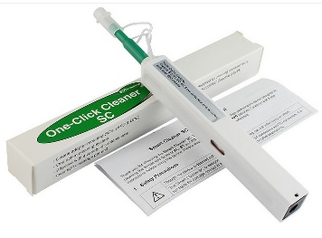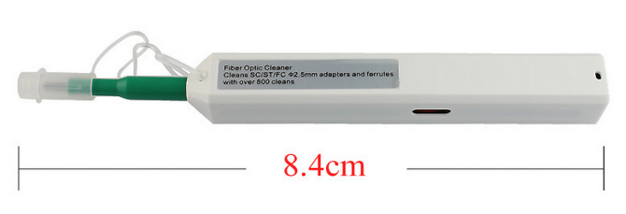
Description:
Fiber Optic BOB-Mini is designed to specially work well with the MU and LC connectors (Φ 1.25mm), this instrument cleans the ferrule end faces removing dust, oil, and other debris without nicking or scratching the end face.
Features:
. One action cleaning system
. Easy pushing motion engages connector and initiates cleaner
. Disposable with 800+ cleanings per piece
. Made from anti-static resin
. Cleaning micro fibers are densely stranded and debris free
. Extendable tip reaches recessed connectors
. Cleaning system rotates 180 for a full sweep
. Audible click when engaged
Applications:
1. Fiber network panels and assemblies
2. Outdoor FTTX applications
3. Cable assembly production facility
4. Testing laboratories
5. Server, switches, routers and OADMS with SC and LC interface

CT-02 Fiber Optic Cassette Cleaner
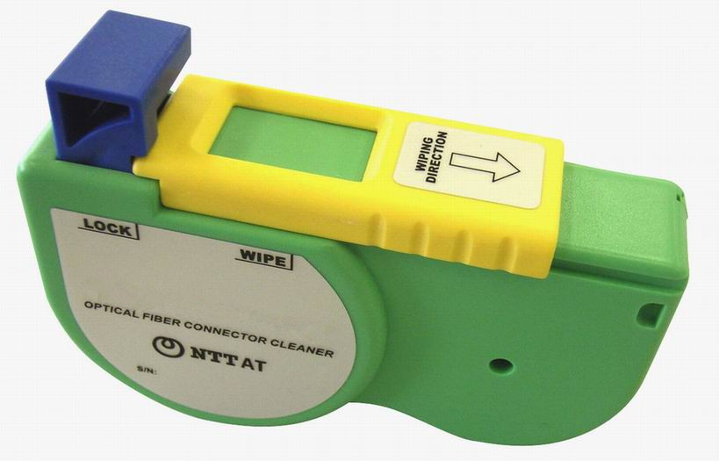
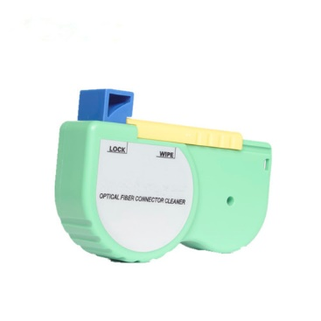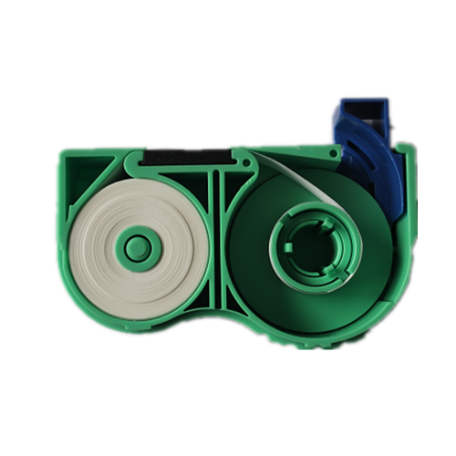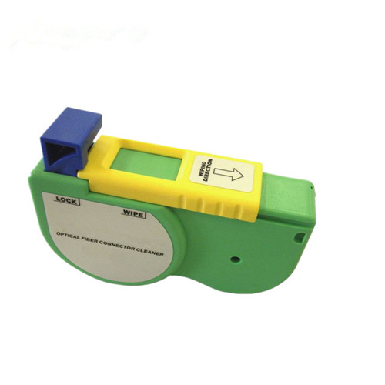
Features:
1). Compact and light weight design
2). Simple push button shutter operation
3). Replaceable clean tape reels are cost effective
4). Over 500 swipes each tape
5). Consistent Cleaning results without alcohol
6). Excellent anti-static properties minimize reattachment of dust to the
connector after cleaning

Specifications:
Connector: SC,FC,ST,MU,LC,MPO,MT,MTRJ
Cleaning time: 500 times
Size(mm): W 115 × H 79 × D 32

CT-04 MPO Fiber Optic Cleaner
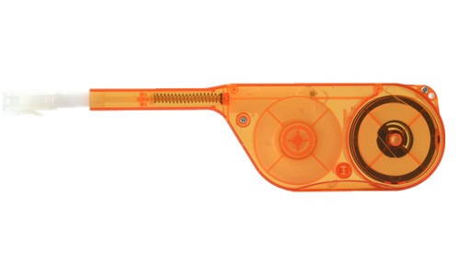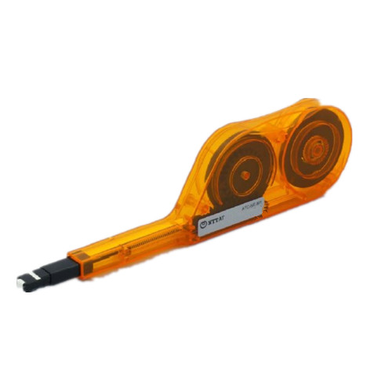
Description:
1). Soft material efficient clean fiber and face.
2). One-time efficient clean MPO & MTP fitting all optical fiber end face.
3). With dedicated superfine fiber, won't fine fiber core
4). Make scratches, simply press the operation to remove dirt
5). Can complete cleaning of more than 600 times
6). Refined design easy to operate, easy to carry
7). Through the loading and unloading of the cap
8). One can clean for the plug with the adapter

CT-05 Fiber Cleaning Wipes Cloth
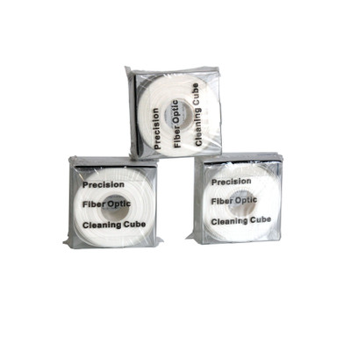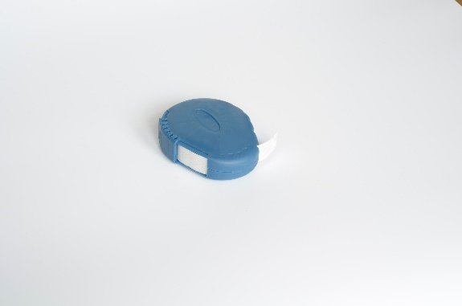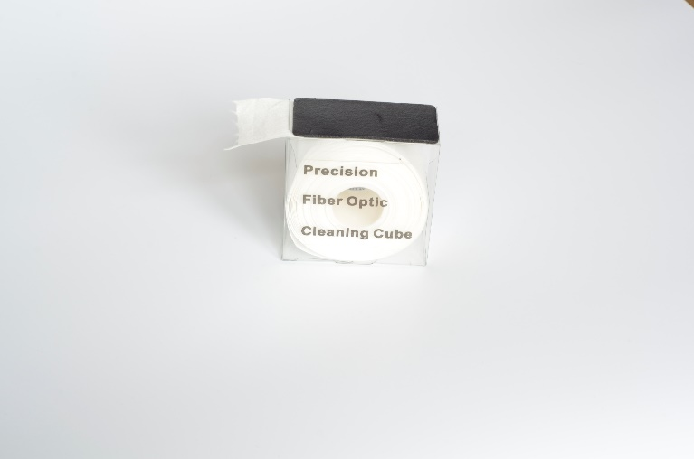
Description:
1. Material: Microfiber Cloth
2. Excellent water and other liquid absorption, extremely low ionic contaminants and extractable.
3. It is so soft and will not hurt the surface of the object
4. Provide adequate wet and dry strength
5. Unlikely to cause a chemical reaction.
6. Application Scope: semiconductor assemble/ aviation/ laboratory electronics industry/ computer assembly/ optical instrument manufacturing/ LCD liquid crystal display/ precision instruments/ optical products/ aviation industry/ and the circuit board production line, especially applicable to the semiconductor industry.
7. using the 18M ultrapure CDI to clean, packing in 100 state-of-the-art clean room; four sides with Laser Edge, hair, fibers decreased, low dust, low ion release
Package:
100 Pieces/Pack 5.0cm*10.0cm / 3.0cm*10.0cm

CT-06 Fiber End Face Cleaning Wipes
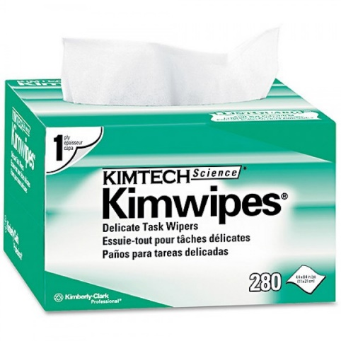
Product Name: low dust wiping paper
Color: white
Specification: 110mm x 210mm
Each package number: 280
100% original pulp with special processing technology, pure texture, high water absorption;
A variety of specifications, to meet different needs.
Applications:
Wipe clean, scientific analysis of precision instruments;
With the solvent for surface cleaning products;
Wipe precision components;
Clean the printing equipment;
Special packaging of components.
Optical communication instrument, optical fiber end cleaning
surface of high-precious instrument.

