Patch Cord

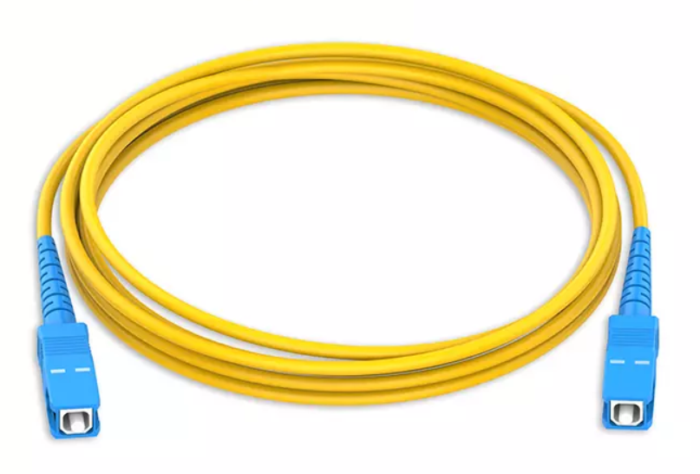
Application:
1).Telecom Net
2).Optical Fiber Sensor
3).Optical Fiber test equipment
4). CATV
5). FTTx, LAN,PON etc.
6). Optical fiber communication system

Features:
1).Low Insertion loss
2).High return loss
3).Good Repeatability
4).Good Interchange
5).Excellent Environmental Adaptability

Specifications:

Fiber Type | SM(G.652)
Cable Type | Single, duplex
Connector Type | SC,FC,LC,
Ferrule Type | PC/UPC,APC
Cable Diameter | Φ2.0mm, Φ3.0mm
Outer Jacket | PVC,LSZH
Reinforced core | Polyester, Aramid
Length | Standard: 1m, 2m, 3m; Customization
Mark: Customization is accepted

