SAT-18EXB Mini OTDR
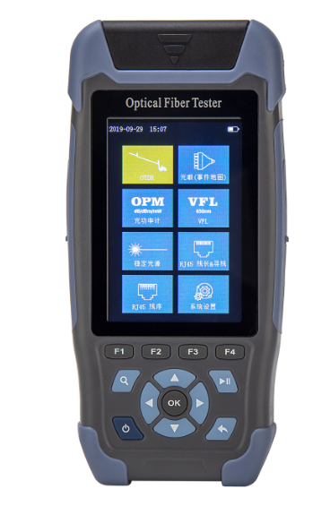
Applicable Scenarios
1. Access Network (FTTx/FTTH)
2. Metro Network (Short to Medium Span)
3. Data Center & Equipment Room
4. Field Deployments & Emergency Restoration
5. Industry Specific Networks (Power, Railway, Metro)
6. Pre-construction Survey & Preliminary Acceptance

Key Features
- Suitable for FTTx and other access network, test fiber’s length, loss, breakpoint etc.
- 3.5“colorful LCD screen, utral-light design for easily carrying,
- 8 in 1: OTDR, OLS, OPM, VFL, iOTA(Event Map),RJ Sequence, RJ length and LED Lighter.
- Universal connector: FC/SC/ST/LC for choice.
- Large internal storage with 600 results, and extensible TF card, USB wire can upload the testing results to PC for printing.
- Built-in 4000mAh li-ion rechargeable battery, can charge by any USB charger, suitable for long-term field working.

General Specification
Screen | 3.5“Colorful LCD screen
Connect Port | FC/UPC(SC、ST available)
Com. Port | Micro USB*1
Results Storage | Internal：≥600；External：TF Card;  File type: SOR Standard file format
Battery Life | stand by>7.5h； testing >4h
Power Supply | 3.7V, 4000mAh lithium battery;  Power adapter:5VDC, 2A.
Working Environments | Working temperature: 0~+50℃，<95%RH
Dimensions/Weight | 173mm*82mm*37mm, <350g

Technical Specification
Dynamic Range |  | 24/22dB
Wavelength |  | 1310nm/1550nm±20nm
Fiber Type |  | SM (G.652)
Event Dead Zone |  | 3m
Attenuation Dead Zone |  | 8m
Pulse Width |  | 3ns to10us
Distance Range |  | 500m to 60km
Measurement Accuracy |  | ± (1m+sample space+0.005%*measurement distance)
Linearity |  | ±0.2 dB/dB
Sample Points |  | 16k~128k
Sample Resolutions |  | 0.05m~8m
IOR |  | ±3dB
VFL | Output Power | 10mW
VFL | Wavelength | 650±20nm
VFL | Working Mode | CW/1Hz/2Hz
VFL | Connect Port | FC/SC/ST
Power Meter | Wavelength | 800nm to 1700 nm
Power Meter | Calibrated wavelength | 850/980/1300/1310/1490/1550/1625 nm
Power Meter | Measurement range | -50 to +26 dBm
Laser  Source | Working Wavelength | 1310nm/1550nm±20nm
Laser  Source | Output Power | ≥-5dBm
Laser  Source | Frequency | 270Hz /330Hz /1kHz /2kHz
RJ45 | Testing Distance | 300m

Packing List
No. | Description | Qty | Remarks
1 | Main Unit | 1 | With battery
2 | Power Adapter | 1
3 | Data Cable | 1
4 | CD  (Including analysis software & user manual) | 1
5 | Operation Manual | 1
6 | SC/UPC Connector | 1
7 | Test Report | 1
8 | Certificate of Conformity /  After-sales Warranty Card | 1
9 | Cleaning Wipes | 10
10 | Instrument Carry Case

