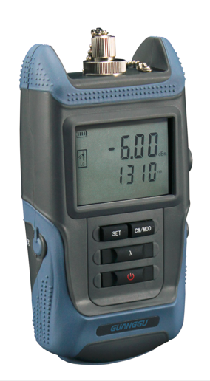
SAT-3E Optical Laser Source
Key Features
- High sensitivity, multi output power
- Multi wavelengths optional, up to four wavelengths on two ports
- Automatic power-off, off time setting range 30~90mins
- Low battery alarm
- LCD display
- New-type conductive rubber switch, suitable for different operation environments.

Technical Specifications
Model | 3E  3E04  3E05  3E06  3E07  3E08
Working  Wavelength(nm) | 1310/1550nm
Output Power (dBm) | 850/1300/1310/1550/1490/1625: -6 (error:±0.2)
Output Tone | 850/1300/1310/1550 /1490/1625: CW, 270Hz, 1KHz, 2KHz; 650: CW
Spectrum Width | ≤ 5nm
Output Stability | ±0.03dB/15min; ±0.05dB/8H
Optical Identity Distance | 5km; 10km/15km optional (650nm)
Display | LCD
Optical Interface | FC, SC, ST
Power Supply | AA alkaline batteries
Operating Temperature | -10---+50°C
Size | L*H*W:140*72*38mm, 0.3kg

