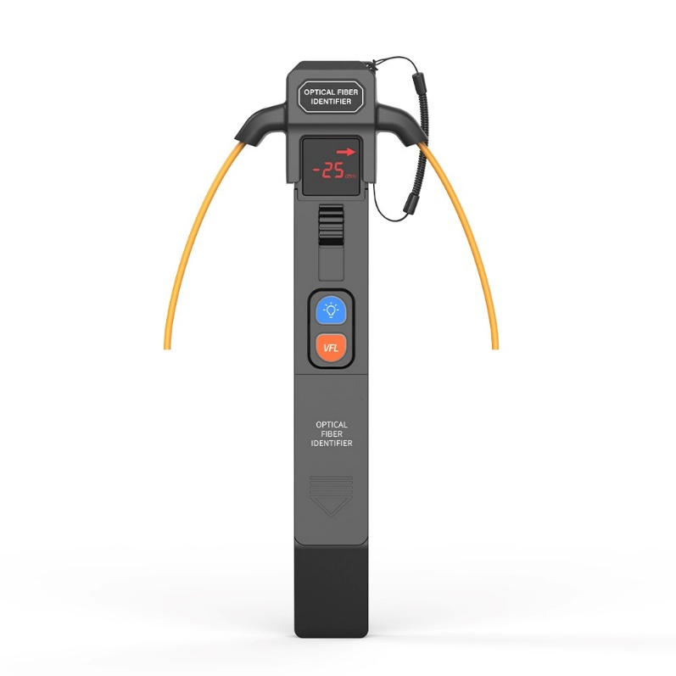
SAT-6C Optical Fiber Identifier
SAT-6C can detect optical signal presence/type and direction anywhere on fibers during optical network deployment, maintenance and troubleshooting. With non-destructive macro-bend detection technology, it introduces no damage to tested fiber or interference to the service on fiber. SAT-6C is able to identify wide-spectrum signals (such as signals in CATV system) and can be used in SONET/SDH & DWDM systems tests.

Key Applications:
- Confirming live fibers – Clamp onto a fiber before maintenance. "Light + service signal" means do not cut or unplug; "no light" means safe to proceed. Prevents accidental service disruption.
- Checking transmission direction – Verifies Tx/Rx orientation during patch cord management, service migration, or route verification in ODFs, avoiding reversed connections.
- Identifying signal types – Detects modulation frequencies (270 Hz, 1 kHz, 2 kHz) to locate target fibers in dense cabling, especially with a modulated light source.
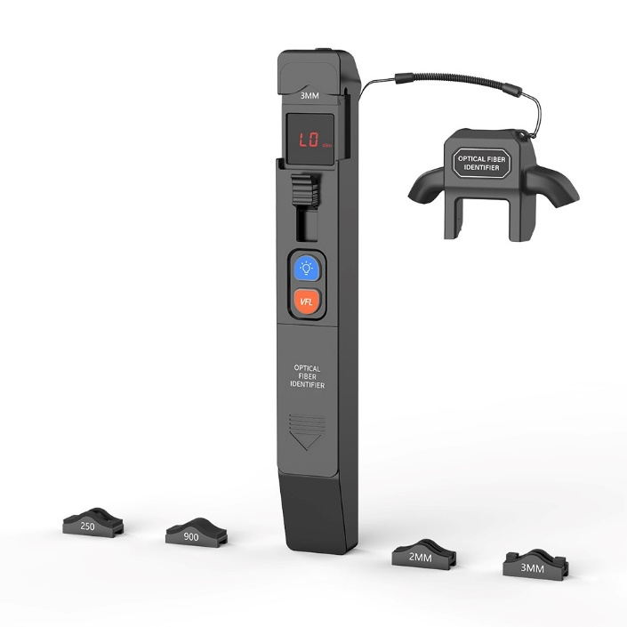
- Wide deployment – Used in carrier equipment rooms, base stations, and data centers; distinguishes downstream/upstream signals in PON networks; serves as a safety tool for live cable operations in military, power, and railway private networks.

Key Features
- Fiber types: 250μm, 900μm,
2mm/3mm jacketed fiber
- Universal for SM&MM
- Support flashlight and VFL
- Indication of signal presence, strength and direction
- CW/MOD tones detection
- Buzzer indication
- Handheld & sturdy

Specification
Model | SAT-6C
ldentified Wavelength Range | 800~1700nm
Detector Type | Φ1mm InGaAs 2 pcs
Signal Type | CW, 270Hz±5%, 1kHz±5%, 2kHz±5%
Display | Signal presence, Signal strength, Signal direction, MOD frequency
Adapter Type | 250um (for bare fiber), 900um/ 2mm/3mm jacketed fiber
Signal Direction | Left & Right LED
Signal Direction Test Range | -40+13dBm
Signal Frequency | 270Hz,1kHz,2kHz
Power Supply | 6F22ND/6LR61
Operating Temperature | -10 ~ 60℃
Storage Temperature | -25 ~70℃
Relative Humidity | 0 ~ 95% (Non-condensing)
Weight | 255g
Dimensions (H×W×T) | 195×80×30mm
VFL | Output power:1mw; Testing range:3~5km; Wavelength:650nm;  Laser type: LD;
Flashlight | Support

