SAT-ACL Portable AC Load
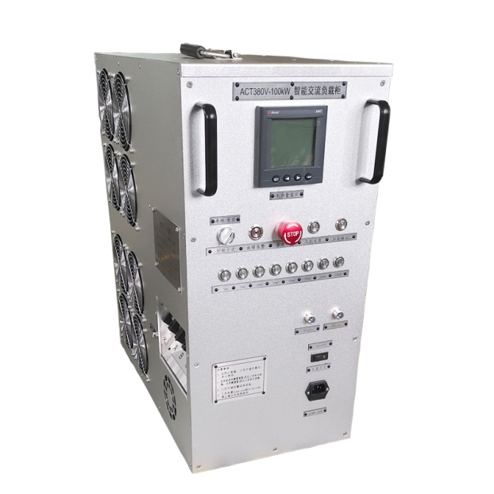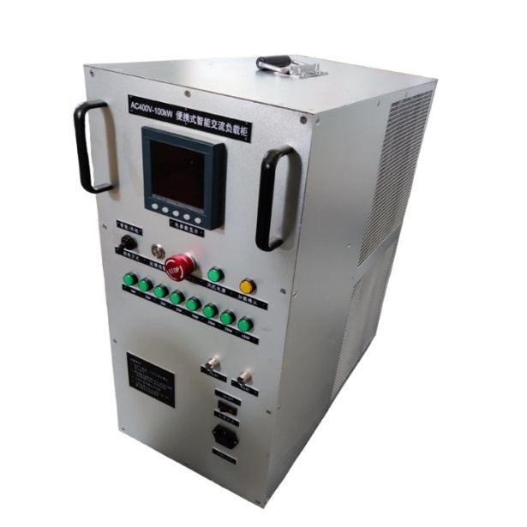
The FAC380 series portable AC load uses the latest discharge power modulation technology to achieve load testing of AC power equipment. It is an essential test instrument for engineering acceptance and daily maintenance of AC power equipment such as backup power supplies, UPS, generators, etc. It can be widely used in performance testing and aging of online high-power UPS, inverters and diesel generator sets in departments such as communications, electricity, civil aviation, and factories and enterprises.
Key Features
- Adopts ultra-high power density design and aluminum alloy outer box layout, with small and light body, 70% lighter than traditional loads of the same power, and can be carried by one person.
- Using the latest high-performance alloy materials, the load does not generate red heat during the test, which complies with UL safety regulations;
- Steady-state test function: automatic test of three-phase voltage, current, active power, reactive power, apparent power, power factor, frequency, running time, power accumulation and other functions;
- Both three-phase power and single-phase power can be tested;
- With overheating protection function, it automatically shuts down the load, terminates discharge and alarms after overheating to ensure equipment safety;
- High test accuracy: load accuracy of 1%, step value 1kW adjustable, can accurately reflect the load capacity of the tested equipment;
- Can be manually controlled and remotely controlled through intelligent software (optional)
- Parallel function: can realize parallel testing of multiple loads to meet the needs of high-power testing;
- Support customization to meet the needs of different power tests.
Specification
Model | ACL-50KW | ACL-100KW
Load power (Max） | 0-50KW | 0-100kW
Rated voltage/frequency | AC three phase four wire:400V/50Hz/60Hz
Compatible voltage | 80V～415V
Step value | 0-100kW continuous adjust，min. step：1kW
Power factor | 1
Load accuracy | ±1%
Display accuracy | 0.5
Insulation level | F
Voltage measurement | Testing range:AC0～450V，resolution:0.1V，accuracy:0.5%
Frequency measurement | Testing range:45～65Hz，resolution:0.1Hz，accuracy:0.2%
Current measurement | Resolution:0.1A，accuracy:0.5%
Cooling method | Fan forced cooling
Communication method | RS485
Working power supply | AC85V～240VOR DC110V～330V
Dimensions | 300mm×540mm×580mm（W×L×H）
Size | About 25/35kg

