SAT-RSL FDC series Rack-mounted simulated load
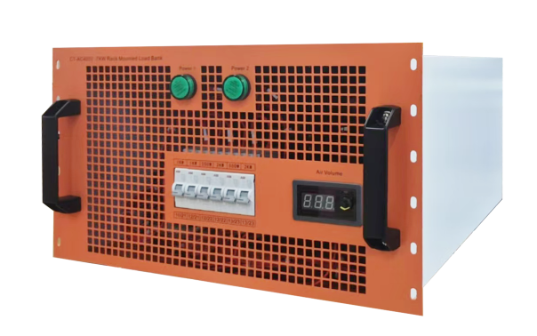
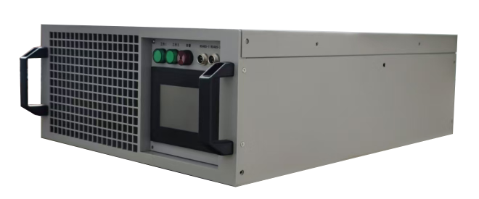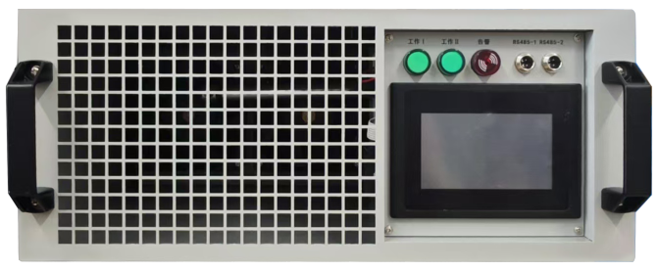

The FDC series rack-mounted simulated load uses the latest discharge power modulation technology. As the end load, it can detect the load capacity of the AC/DC system and the performance of the backup battery pack. The device can fully simulate the power usage, heat dissipation and other air flow changes of the server. It is widely used in the output power, heat dissipation and load capacity testing of the power distribution system of data centers and operator IDC computer rooms.

Key Features
- Meet the test of the most commonly used power supply systems in IDC computer rooms, such as AC220V, DC240V, DC336V, DC110V, and DC48V;
- Compact structure, standard 19-inch 3U/4U design, can achieve a maximum test power of 10KW;
- Support constant current, constant resistance, and constant power test modes, can simulate the actual load of the computer room after the mains power is interrupted, so as to conduct a comprehensive test and evaluation of the power supply capacity of the backup battery;
- With overvoltage, overcurrent, and overheating automatic protection functions;
- Automatically cut off the discharge power part in case of abnormal conditions to ensure equipment safety;
- Adopting the latest high-efficiency alloy materials, the load does not generate red heat during the test, which complies with UL safety regulations;
- High test accuracy, power accuracy deviation <2%, can accurately reflect the load capacity of the tested equipment;
- Optional segmented digital voltage, current meter, LCD power meter;
- Manual control, multi-device parallel operation, remote control (optional)
- Support customization to meet the needs of higher power testing.
Specification
Model | Voltage range | Power | Size
FDC220V/240V-6KW | DC180V-DC300V  （Constant current, constant resistance, constant power） | O-6KW | 450*134*480mm
48V-9KW | DC24V-DC60V  （Constant current, constant resistance, constant power） | 0-9KW | 450*134*480mm
110V-7KW | DC80V-DC150V  （Constant current, constant resistance, constant power） | 0-7KW | 450*134*480mm
336V-5KW | DC220V-DC400V  （Constant current, constant resistance, constant power） | 0-5KW | 450*134*480mm
Function and power can be customized according to user needs

SAT-ACL Portable AC Load
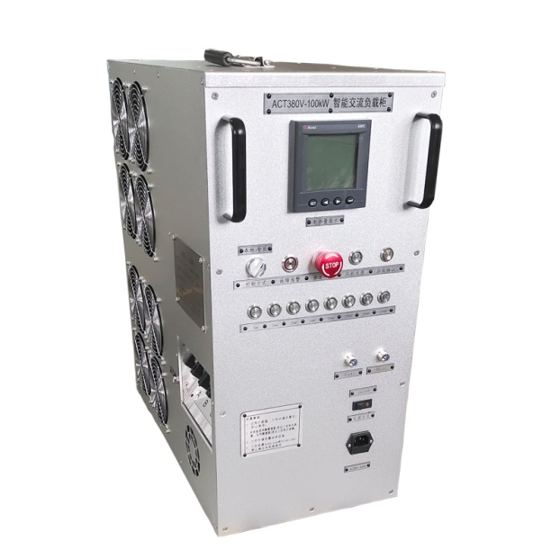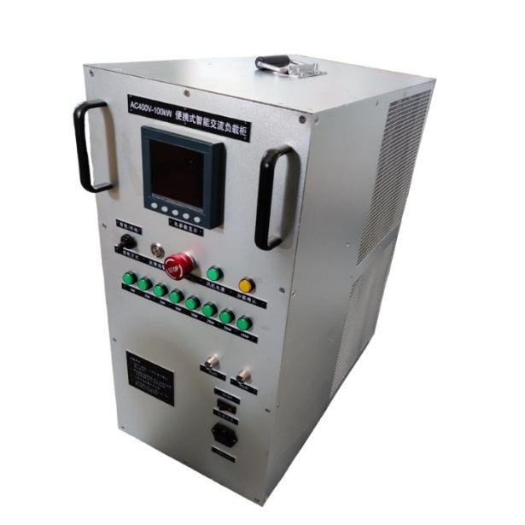
The FAC380 series portable AC load uses the latest discharge power modulation technology to achieve load testing of AC power equipment. It is an essential test instrument for engineering acceptance and daily maintenance of AC power equipment such as backup power supplies, UPS, generators, etc. It can be widely used in performance testing and aging of online high-power UPS, inverters and diesel generator sets in departments such as communications, electricity, civil aviation, and factories and enterprises.
Key Features
- Adopts ultra-high power density design and aluminum alloy outer box layout, with small and light body, 70% lighter than traditional loads of the same power, and can be carried by one person.
- Using the latest high-performance alloy materials, the load does not generate red heat during the test, which complies with UL safety regulations;
- Steady-state test function: automatic test of three-phase voltage, current, active power, reactive power, apparent power, power factor, frequency, running time, power accumulation and other functions;
- Both three-phase power and single-phase power can be tested;
- With overheating protection function, it automatically shuts down the load, terminates discharge and alarms after overheating to ensure equipment safety;
- High test accuracy: load accuracy of 1%, step value 1kW adjustable, can accurately reflect the load capacity of the tested equipment;
- Can be manually controlled and remotely controlled through intelligent software (optional)
- Parallel function: can realize parallel testing of multiple loads to meet the needs of high-power testing;
- Support customization to meet the needs of different power tests.
Specification
Model | ACL-50KW | ACL-100KW
Load power (Max） | 0-50KW | 0-100kW
Rated voltage/frequency | AC three phase four wire:400V/50Hz/60Hz
Compatible voltage | 80V～415V
Step value | 0-100kW continuous adjust，min. step：1kW
Power factor | 1
Load accuracy | ±1%
Display accuracy | 0.5
Insulation level | F
Voltage measurement | Testing range:AC0～450V，resolution:0.1V，accuracy:0.5%
Frequency measurement | Testing range:45～65Hz，resolution:0.1Hz，accuracy:0.2%
Current measurement | Resolution:0.1A，accuracy:0.5%
Cooling method | Fan forced cooling
Communication method | RS485
Working power supply | AC85V～240VOR DC110V～330V
Dimensions | 300mm×540mm×580mm（W×L×H）
Size | About 25/35kg

SAT-LCL Rack mounted AC/DC liquid cooling load
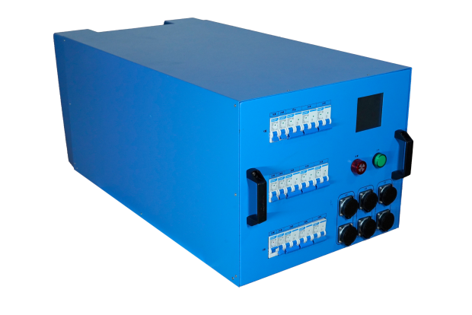
With the water cooling of data centers, "liquid cooling" technology is the most reliable and feasible solution to reduce the energy consumption of data centers. Liquid cooling load can simulate the actual heat generation and power consumption of real servers in the server room, detect the liquid cooling effect of the server room and the power safety of the server room lines, and provide data basis and testing methods for the reliability of the server room system. The liquid cooling load box adopts a modular design, which is easy to maintain and replace. It can be used alone or in parallel with multiple machines, and each gear can be adjusted.
- Load simulation: can simulate the actual heating situation of the server in the computer room, cooling effect, power supply load capacity, line reliability verification, etc.;
- Control mode: can control the load power increase/decrease through a multi-position switch;
- Temperature protection: when the load temperature exceeds the set safety threshold, an audible and visual alarm prompts;
- Monitoring function: the device can be equipped with an LCD display to display the temperature, flow rate, alarm and other information of the inlet and outlet water;
- Parallel expansion: can realize parallel testing of multiple loads to meet the needs of high-power testing.

Technical parameters
Rated voltage/frequency | AC three-phase, single-phase voltage:220V/50Hz  DC 270V
Rated power | 36KW (single-phase 12kW@ AC220V/50Hz)  Load step：1kW、2kW、3kW、3kW、3kW;(A、B、C three steps)  When the voltage changes, the gear power changes based on AC220V according to Ohm's law.
Load materials | PTC
Power factor | 1
Heat transfer efficiency | ≥95%
Fully load accuracy | Accuracy≤±5%
Main circuit power interface | 2 per phase, interface with protective cover
Load Method | Gear switch (miniature circuit breaker)，manual loading
Power control | Adopt the power interface under test for power supply
Isolation level | AC1000V，isolation resistance ≥10MΩ
Inlet water temperature | 2-100°
Water interface | 1 inlet pipe and 1 return pipe, clamp-type quick connector,  pipe diameter: DN25
Pressure | Liquid cooling container or resistor withstands 1.0MPa working pressure, and the ultimate test pressure is 1.5 times the working pressure
Airtightness | No leakage for 2 hours under 1Mpa pressure
Water flow | 1-10m³/h
Cooling method | High grade pure water cooling
Isolation grade | F
Protection grade | IP24
Working method | Continuous working
Pipe material | Stainless steel 304
Pannel display | The load panel has a power working indicator light and a fault alarm indicator light.  It has an inlet and outlet water temperature sensor to display the temperature and current, voltage, and power data (LED instrument), and the sensor accuracy is 0.5 level.
Over-heat protection | The load carries the water temperature monitoring of the inlet and outlet. When the water temperature is abnormal, the alarm prompts and the load is unloaded. The upper limit of the inlet and outlet temperature alarm is adjustable (default: 80℃)
Overcurrent protection | When the switch is in overcurrent protection, the switch trips and cuts off the overcurrent load;
Grounding protection | The ground wire of the load input port is connected to the chassis, and the chassis grounding terminal is for users to use for grounding.
Short circuit protection | The load short-circuit switch trips and cuts off the load
Load modular design | The load adopts modular design and can be used as a single module or in parallel
Size | 430mm*720mm*289mm(L*W*H) blue
Weight | 55kg
Transportation | The side is equipped with lifting handles for easy transportation;
Working temperature | -15℃～+70℃
Relative humidity | 0-95%RH，Non-condensing
Altitude | ≤2500m
Atmospheric pressure | 86～106kPa
Installation conditions | For indoor use, no flammable gas around

