SAT-WSA4020 40G Spectrum analyzer
Aitelong SAT-WSA handheld spectrum analyzer covers 9K-40G spectrum, the instrument can achieve signal monitoring and analysis, satellite signal analysis, signal coverage test, and communication interference troubleshooting. It is available for testing base stations, satellites, internet of vehicles, wireless terminals, radio stations and other equipment. This device provides test support for operators, operation and maintenance providers, equipment manufacturers and wireless spectrum monitoring organizations.
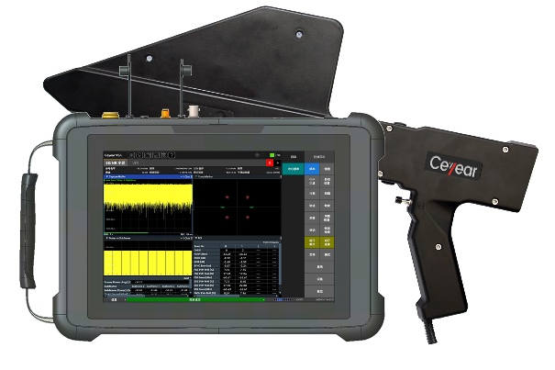
Basic function
- Base station analysis: 5G NR、LTE、WCDMA、NB-IoT、GSM、satellite protocol
- Signal analysis: AM/FM/PM/LSB/USB、ASK/FSK/MSK/PSK/QAM etc.
- Drive Test: Indoor signal coverage, outdoor drive test.
- Interference analysis: Waterfall measurement; afterglow spectrum; signal direction finding; interference location; four-window interference troubleshooting; TDD system interference troubleshooting, etc.
- Test analysis: Spectrum scanning, field strength measurement, channel power, OBW, ACLR, 100MHz real-time spectrum, spectrum emission template, signal-to-noise ratio, harmonic distortion, phase noise, differential spectrum, zero span, signal strength, channel scanning, audio demodulation, etc.

Key Features
- Spectrum range: 9kHz~4.4GHz/6.3GHz/7.5GHz/9GHz/20GHz/40GHz
- Support many varieties function of base station analysis, such as
5GNR/TDD-LTE/FDD-LTE/WCDMA/NB-IoT/GSM
- Reach up to 1000MHz actual time bandwidth analysis
- Support TDD system upstream and downstream separation interference troubleshooting test
- Download the IQ data, support the third software to analyze the IQ data
- Afterglow spectrum, effectively monitor the superposition or burst signal
- Directional antenna with electronic compass for signal direction finding, supporting multi-point positioning function;
- Support wireless communication road test, and realize automatic positioning road test function with GPS;
- 10.1-inch capacitive touch screen with multiple operating modes such as "day mode" and "dark mode";
- Small size and slight weight≤2.4kg
- Battery power supply≥3 hours
- Easy to carry,support remote control.

Technical Parameters
Frequency range | 9kHz~4.4GHz/6.3GHz/7.5GHz/9GHz/20GHz/40GHz
Frequency accuracy | ±1ppm
Phase noise | ≤-106dBc/Hz@10kHz offset 1GHz  ≤-127dBc/Hz@1MHz offset 1GHz
Average noise level | Amplifier close  (Not 40G device) |  | Amplifier close  (Not 40G device)
Average noise level | 100kHz～50MHz：-142dBm/Hz |  | 100kHz～50MHz：-145dBm/Hz
Average noise level | 50MHz～6.3GHz：-148dBm/Hz |  | 50MHz～6.3GHz：-164dBm/Hz
Average noise level | 6.3GHz～9GHz：-148dBm/Hz |  | 6.3GHz～9GHz：-161dBm/Hz
Average noise level | 9GHz～20GHz：-145dBm/Hz |  | 9GHz～20GHz：-160dBm/Hz
Average noise level | Amplifier open (40G device)  88MHz～9GHz：-140dBm/Hz  9GHz～30GHz：-145dBm/Hz  30GHz～40GHz：-142dBm/Hz
Level accuracy  (Level testing uncertainty) | ±1.5dB（9kHz~4.4GHz/6.3GHz7.5GHz/9GHz/20GHz）
Level accuracy  (Level testing uncertainty) | ±2dB（9kHz~40GHz）
Level resolution | 0.1dB
Max. input safe power | 26dBm（9kHz~4.4GHz/6.3GHz）  23dBm（9kHz~7.5GHz/9GHz/20GHz/40GHz）
Third-Order Intercept Point | 100kHz～3GHz : ≥+10dBm
Third-Order Intercept Point | 3GHz～6.3GHz : ≥+12dBm
Second Harmonic Distortion | <-75dBC
Remaining Responses | <-90dBm
Reference level range | -130dBm～+30dBm
VSWR | <2.0
Real-time spectrum analysis bandwidth | Max 100MHz
Analog signal analysis | AM、FM、PM、LSB、USB
Demodulation analysis support mode | 5G NR、LTE、WCDMA、GSM、NB-IoT、Satellite protocols, vector signals, audio analysis
Demodulation indicators | 5G NR | 1.2%@2.6GHz (PSS channel)
Demodulation indicators | 5G NR | 1.3%@2.6GHz (SSS channel)
Demodulation indicators | 5G NR | 1.0%@2.6GHz (PBCH channel)
Demodulation indicators | LTE | 1.2%@1.8GHz (QPSK modulation)
Demodulation indicators | LTE | 1.7%@1.8GHz (16QAM modulation)
Demodulation indicators | Vector signal | 0.8%@1.8GHz (symbol rate1Msps QPSK)
Demodulation indicators | Vector signal | 1.3%@1.8GHz (symbol rate 1Msps 64QAM)
Power | AC：100~240V/50~60Hz DC：19V
Temperature | -10℃~50℃
Screen | 10.1” TFT touch screen
Size | L*H*W：311mm*206mm*61mm
Weight | 2.4kg

