SAT-WSG Vector Signal Generator

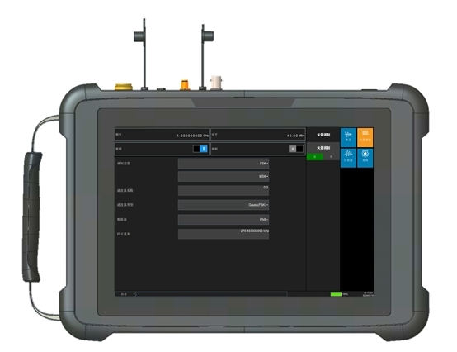
The communication vector signal generator is a handheld signal generator with 8-inch TFT touch screen, the frequency range of 250kHz~6GHz, supports multiple communication standards such as 5G NR, 4G LTE, NB-IoT, WCDMA, CDMA2000, GSM and vector modulation, it also has multiple modulation functions such as analog modulation, digital modulation and pulse modulation. The max. modulation bandwidth is 80MHz, which is suitable for various application scenarios such as R&D, production, and training etc.

Function
●Simulation of multiple communication signal formats: can effectively simulate 5G, 4G, 3G and 2G communication signals specified by the 3GPP protocol, and has multiple test templates specified by the protocol;
●Pilot signal simulation: can effectively simulate the pilot signals generated by 5G and 4G base stations to complete indoor distribution system testing;
●Simulation of multiple modulation signal formats: BPSK, DBPSK, QPSK, OQPSK, DQPSK, pi/4DQPSK, QAM, ASK, FSK and GFSK and other digital modulation signals, symbol rate: 3kHz-50MHz;
●Generation of multiple analog modulation signals: AM, PM, FM and other analog modulation signals;
●High-power signal simulation: can effectively and continuously output high-power signals, with a max. support of 30dBm, and can effectively simulate a variety of indoor and outdoor high-power interference signals;
●Custom signal simulation: can flexibly load user-defined .txt, .wv and .bin and other data format file signals.

Features
●Frequency range: 250kHz~6GHz.
●Frequency accuracy: ±0.28ppm.
●Frequency resolution: 1Hz.
●Output power range: -55dBm~10dBm.
●Output power accuracy: ±1.5dB.
●Modulation bandwidth: 80MHz@frequency>50MHz.
●Single Sideband Phase Noise: ≤-122dBc/Hz (Carrier 1GHz, frequency deviation 10kHz)
●AM/FM/PM/PSK/QAM/FSK/Pulse modulation and other multi-standard signal generation
●Multiple digital communication standards, including 5G NR,4G LTE,NB-IoT,
WCDMA, CDMA2000, GSM and Vector Modulation.
●Screen: 8inch TFT touch screen.
●Battery continuous working:2 hours
●Weight: 3kg
●Temperature: -10℃~50℃

Technical parameters

Model:5252D | Parameter
Frequency range | 250kHz~6GHz
Frequency accuracy | ±0.28×10⁻⁶
Frequency resolution | 1Hz
Output power range | -55dBm~+10dBm(With amplifier version max power≥30dBm)
Power accuracy | ±1.5dB
Single Sideband Phase | ≤-122dBc/Hz@10kHz (carrier 1GHz)
harmonic | ≤-35dBc (Output Level 0dBm)
Non-harmonic | ≤-50dBc (Output Level 0dBm)
Max. modulation bandwidth | 80MHz@frequency>50MHz
EVM | ≤1.5% rms (carrier 1GHz, Symbol Rate  4MHz, Modulation: QPSK)
LCD Screen | ≥8 inch
Battery life | ≥2h
Weight | ≤3kg
Structure | Handheld

